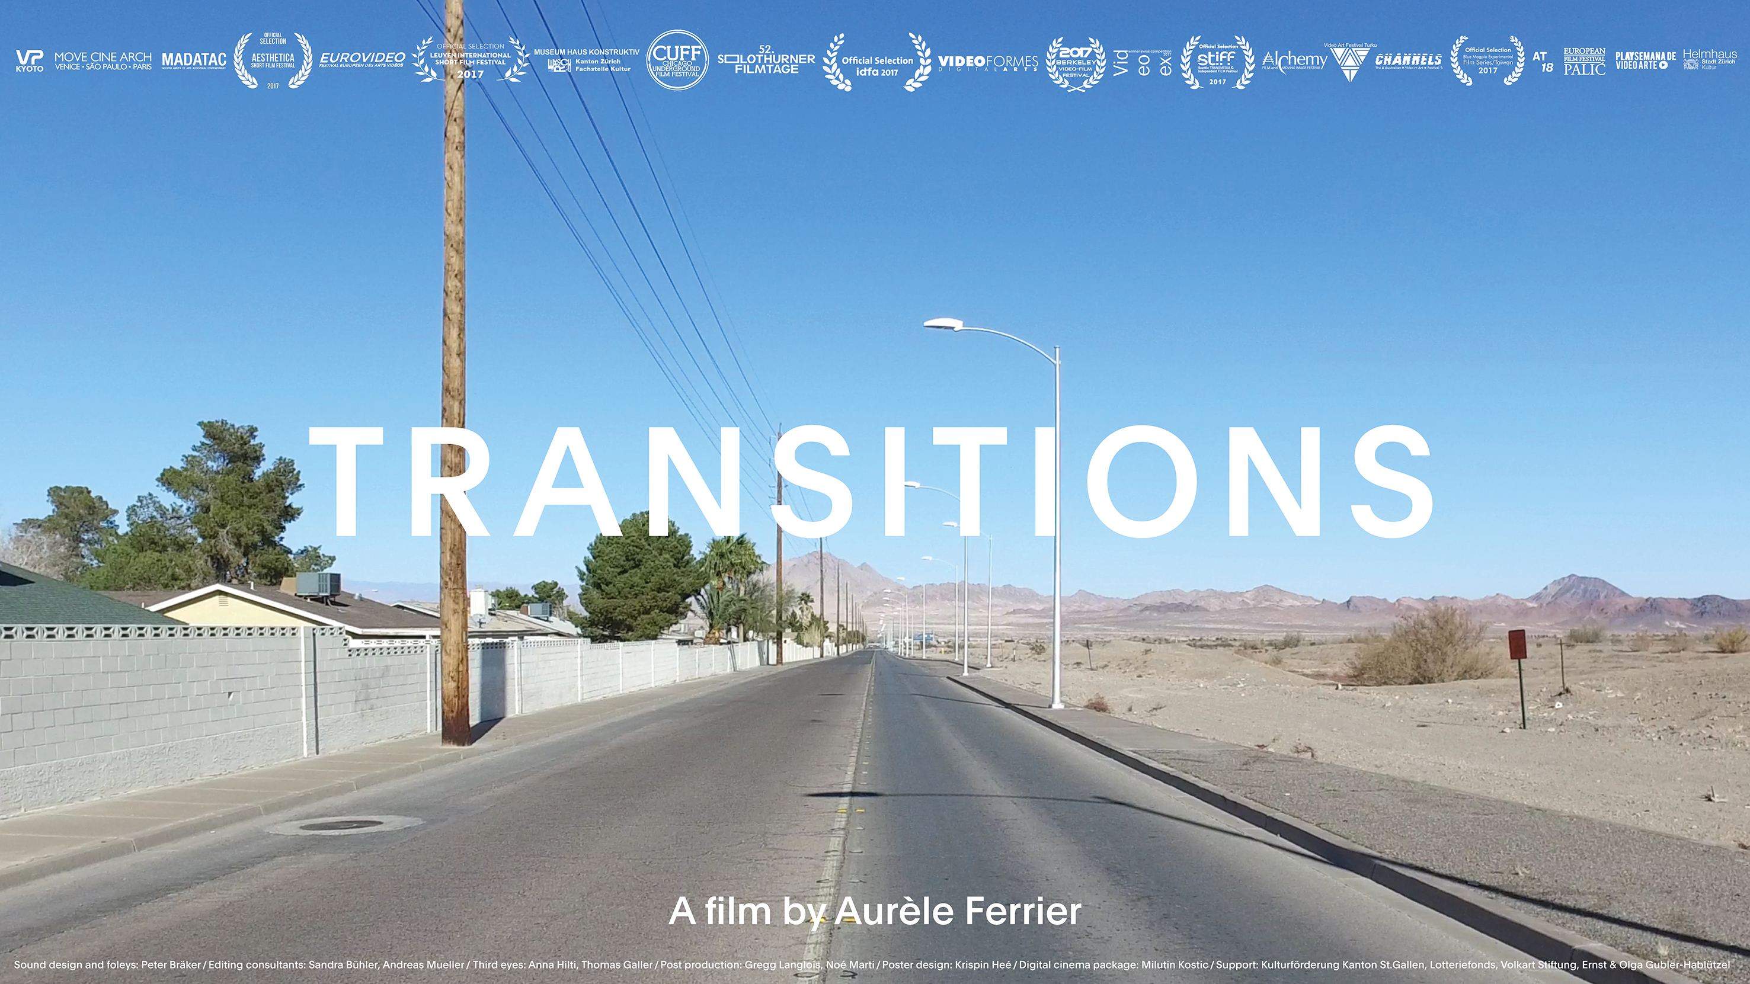
film poster (Krispin Heé)

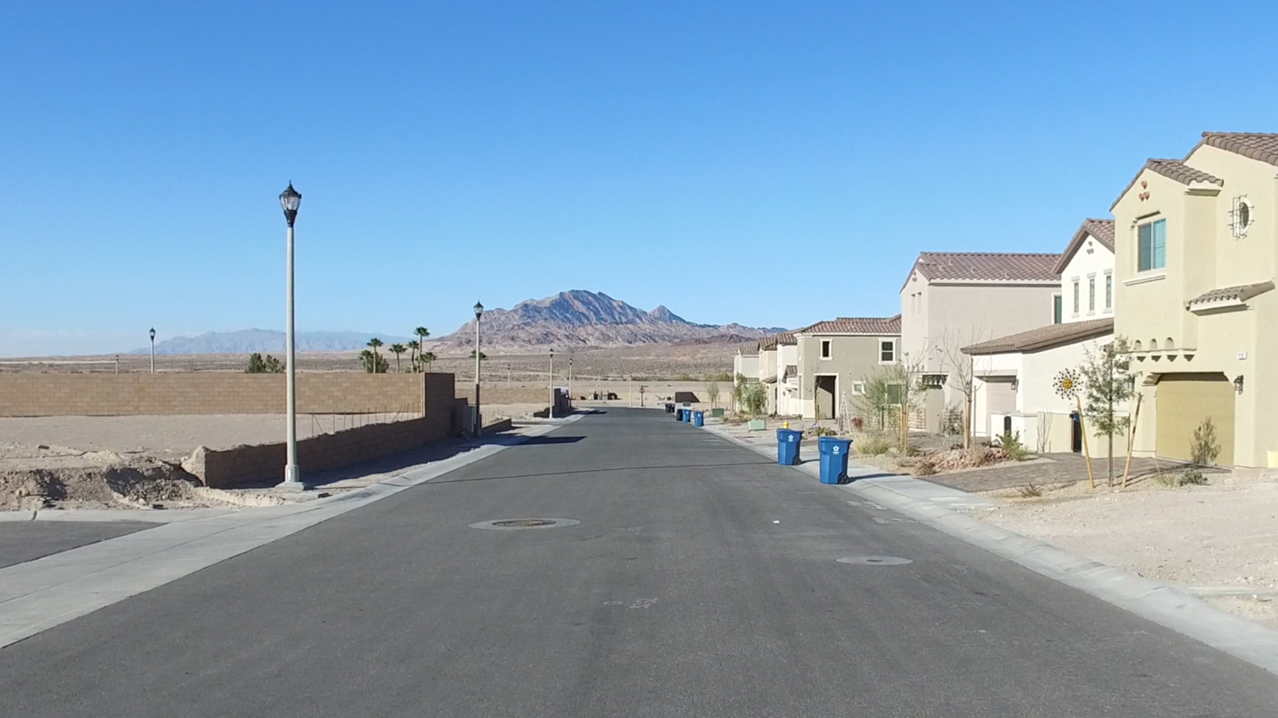
film still

TRANSITIONS, CH 2017
DCP, 1:1.85, Dolby Surround 5.1 / Single-channel-video-installation HD 16:9, stereo (no dialogues), 12:48 min.

Synopsis
TRANSITIONS is a journey from the civilizing void of the desert to a maximal urban, capitalistic and hedonistic density, which in the case of Las Vegas assumes some bizarre expression. The film is a contemplation without any people or moving machines in it, focussing on the built and designed.
Text by Esther Eppstein & Elodie Pong:
The work Transitions (2017) by Aurèle Ferrier examines the traces left by human civilisation - the conquest of the unwelcoming hostility of the desert ends in the surreal and hedonistic consumerism of Las Vegas. The camera leads us, with a menacing langour, through a backdrop of deserted city-outskirts. The buildings, cars and billboards speak of people’s dreams as they strive for a version happiness. The prevailingly eerie, apocalyptic mood draws you along on this filmic journey. These traces of humanity seem increasingly laughable and helpless, they vibrate with a peculiar
melancholy. Where have the people disappeared to? One has the impression a catastrophe has occurred, an epidemic, or maybe it is simply an empty film set after a shoot? The film with its calm and assured grasp on image and sound is able to produce a refined suspense. The film takes the viewer on an odyssey, one that could also be a metaphor for the boundaries of human endeavor. The human culture and civilisation that emerged from the desert, will in the end be desert again.

Awards
2018 Best audiovisual art work, MADATAC Videoart & New Media Audio-Visual Art, Madrid
2018 Formal Innovation Prize, Eurovideo, Vidéographies International Video Art Association, Liège
2017 Fine Arts Grant, Canton Zurich
2017 Winner Swiss Competition, Videoex Intl. Experimental Film & Video Festival, Zurich

Screening history
2017 IDFA, 30th Documentary Film Festival Amsterdam
2018 25th Chicago Underground Film Festival, Chicago
2018 33rd Videoformes, Video Art & Digital Cultures, Clermont-Ferrand
2018 Eurovideo, Festival Européen des Arts Vidéos, Videographies Int. Video Art Association, Liège
2018 Madatac, Videoart & New Media Audio-Visual Art, Madrid
2018 Video Party, Kyoto
2018 Open City Documentary Festival, London
2018 Architekturtage, Haus der Architektur Graz
2018 Alchemy Film & Moving Image Festival, Hawick
2018 Video Art Festival Turku
2018 Mostra de Arte do Audiovisual do Barreiro, Barreiro Belo Horizonte
2018 International Architecture Film Festival Move Cine Arch, Venice / Sao Paulo / Paris, Venice
2018 Drunken Film Fest, Bradford
2018 Video Art Miden, Kalamata
2018 Screening, FokiaNou Art Space, Athens
2018 The Unseen Festival, Denver
2018 25th European Film Festival, Palic
2017 IDFA, 30th Documentary Film Festival Amsterdam
2017 52. Solothurn Film Festival (world premiere, Jan 20 2017), Solothurn
2017 Werkschau 2017, Fine Arts Grants of Canton Zurich, Museum Haus Konstruktiv, Zurich
2017 Fine Arts Grants Exhibiton City of Zurich, Helmhaus, Zurich
2017 26th Berkeley Video & Film Festival, Berkeley
2017 Leuven International Short Film Festival, Leuven
2017 Channels, The Australian Video Art Festival, Conditional Surplus, Melbourne
2017 Aesthetica Short Film Festival, York
2017 Seattle Transmedia & Indepentend Film Festival, Transmedia Gallery, Seattle
2017 Videoex Intl. Experimental Film & Video Festival, Zurich
2017 Play, Semana de Video Arte, Centro Cultural Universitario, Córdoba (Argentina)
2017 UMW Media Wall, Moving Image Exhibition, Universtity of Mary Washington, Fredericksburg
2017 Blue Magpie Experimental Film Series, Film Center at National Chiao Tung University, Hsinchu

Credits
A film by Aurèle Ferrier — sound design and foley artist: Peter Bräker — post production: Gregg Langlois, Noé Marti — editing consultants: Sandra Bühler, Andreas Mueller — third eyes: Anna Hilti, Thomas Galler — poster design (coming soon): Krispin Hée — support: Kulturförderung Kanton St.Gallen (fine arts commission/film commission), Volkart Stiftung, Ernst und Olga Gubler-Hablützel Stiftung — production: Aurèle Ferrier Filmproduktion
Collaborators
— Peter Bräker, sound designer and foly artist (selection): Aloys (2016, T. Nölle), Cure (2014, A. Štaka), Yalom's Cure (2014, S. Gisiger), Infrastructures (2014, A. Ferrier), Mary Mary Queen of Scots (2013, Th. Imbach), Bird’s Nest - Herzog & De Meuron in China (2008, Ch. Schaub), Gambling, Gods and LSD (2002, P. Mettler)
— Noé Marti, video and post-production (selection): Zilla Leutenegger (video art), Karim Patwa (film), Dschoint Ventschr Filmproduktion, Schweizer Fernsehen, Prof. for AfterEffects/Animation (HSL, ZHDK), Condor Films
— Gregg Langlois, video and film post-production Paris (selection): The Fountainhead (2010, Société Réaliste/F. Grof/J.-B. Naudy), Banda Bilili (2010, R.Barret/F. de La Tullaye), We don't care about music anyway (2008, C.Dupire/G. Kuentz), Bouzkachi (2008, J. Debs/Les Films d'Ici/Arte)

ISAN: 0000-0004-5097-0000-U-0000-0000-L
SWISS FILMS short films
www.swissfilms.ch
www.aureleferrier.ch
Contact: Aurèle Ferrier, Förrlibuckstrasse 236, 8005 Zürich, Switzerland, studio@aureleferrier.ch

