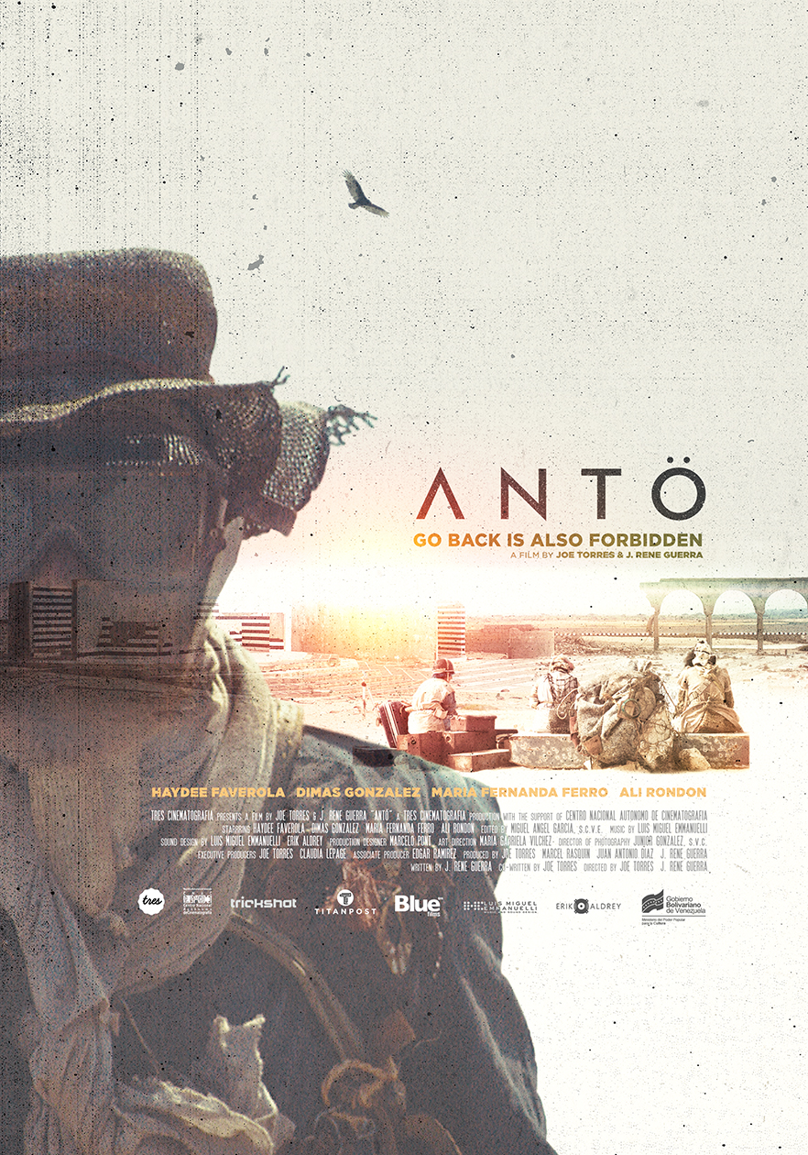

Logline:
Three women await the transport to travel to the only place in the planet where they are allowed screaming.

Synopsis:
The inclement sun. A damn endless desert. Three women gather to wait for transportation. They are survivors of an extinct world, of a time apart. They are afraid. They are suspicious of each other.

In this world of rags and remains almost everything is forbidden, even screaming. That is why they wait for a truck that should be taking them to the only place where is allowed to do it. Restlessness leads to terror, to madness. Now the three strangers are driven to break the system rules and try to blow off steam outside “the screamer”.

A henchman watches them with sarcasm and contempt. He reminds them once and again to suppress their impulses or they will be punished.
After long hours under the sun the three women cave and start shouting. They are heard and get the full extent of the law, erasing them with no mercy.
In this desert resignation is the only option. In this desert the sand also screams.

Technical Data:

ANTÖ will meet the highest technical standards in digital HD cinematography. We will shoot in ARRI Alexa cameras, Ultra Prime optics and go directly to Apple ProRes 444 compression as our final working format. This way we guarantee a very stable post-production workflow and international quality.

All post-production will be done based on the Apple ProRes 444 format, meeting the highest logarithmic color space data rate, including the Digital Cinema output (dcp) in REC709.

We will work on a “non destructive” pre-production and production process. We will create daily pre-colorized files with metadata and synchronized audio (Apple ProRes 422 Proxy) on set for editing. This “dailies” will be delivered to the Chief Editor for montage, while we keep the original HR material until the On-Line Stage of the process.

As for frame rate, we will shoot 30/60fps with synchronization for NTSC and HD standards.

Our final playback will be 24fps for Cinema and 30/60fps for Digital.
Aspect Ratio will be CinemaScope 2:35.1.

Cast & Crew:

TRES CINEMATOGRAFIA presents
A film by JOE TORRES / J. RENE GUERRA

“ANTÖ”
Starring HAYDEE FAVEROLA
DIMAS GONZALEZ
MARIA FERNANDA FERRO
ALI RONDON
Production Designer MARCELO PONT
Art Direction MARIA GABRIELA VILCHEZ
Director of Photography JUNIOR GONZALEZ, SVC
Edited by MIGUEL ANGEL GARCIA, SCEV
Music by LUIS MIGUEL EMMANUELLI
Sound Design by LUIS MIGUEL EMMANUELLI / ERIK ALDREY
Executive Producers JOE TORRES / CLAUDIA LEPAGE
Produced by JOE TORRES / MARCEL RASQUIN / JUAN ANTONIO DIAZ / J. RENE GUERRA
Associate Producer EDGAR RAMIREZ
Written by J. RENE GUERRA
Co-Written by JOE TORRES
Directed by JOE TORRES / J. RENE GUERRA

A TRES CINEMATOGRAFIA production with the support of CNAC

Joe Torres: Director / Producer /Executive Producer

"think first and then shoot or simply shoot".
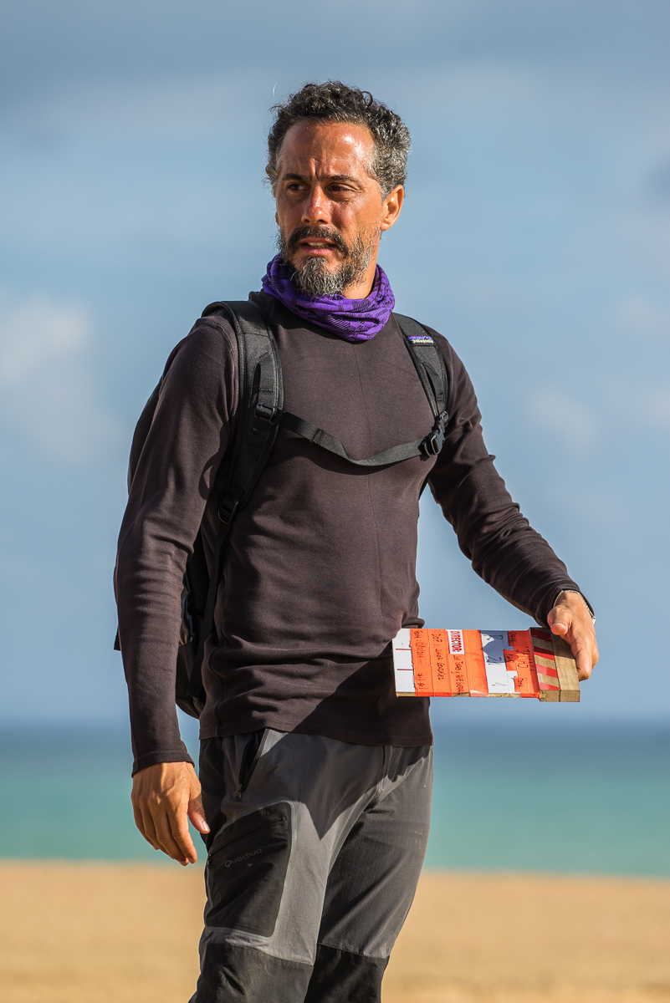
His professional career began 20 years ago in Venezuela, his home country. There, he was brought up as a Producer and First Assistant Director, until he became Production Director for A&B Producciones, one of the main and most acknoledged production companies in advertising film in the country. Meanwhile, he got his degree for Mass Communications, specialized in Audiovisual Arts, from the Andres Bello Catholic University (Universidad Católica Andrés Bello).
Soon after, along with the production company Warm Weather Filmco, he became part of the Venezuelan crew for the feature film “Dragonfly” – Universal Pictures USA by Tom Shadyac – as Second Assistant Director.

The inquisitiveness to continue his education compels him to move to Barcelona, Spain, in October 2003. In Barcelona, he got two master’s degree at the Autonomous University of Barcelona (Universidad Autónoma de Barcelona): the first one in Creative Documentary Theory and Practice y the second one in Screenwriting for Film and Television.

In mid-2004, he premiered his first short film “Dostrece”. A documentary short broadcasted internationally through International Spanish Television (Televisión Española Internacional) in its channel Great Documentaries (Grandes Documentales) and officially selected by the 5th Documentary and Photogragh Showing of Latin America, in Spain 2005. The next year, he premiered a medium-length film titles “elTALLER”, official selection of the 4th International Musical Documentary Film Festival, In-Edit Beefeater, Spain 2006.

At the end of that same year he create, joined by Fermín Cimadevilla, the multidisciplinary directing duet WeArePacheco and work together for the next four years. During this short period, WeArePacheco emerged as one of the most attractive and awarded duets in international advertising, with more than fifty national and international awards. Just the campaign “The town where nothing ever happens”, by the Madrilenian agency Shackleton, won seven Lions at Cannes 2009, becoming the fourth more awarded campaign worldwide, according to The Big Won Report.

In 2011 he returned to Venezuela and founded, partnered up with Marcel Rasquin and Juan Antonio Díaz, Tres Cinematography. Tres, after four years of acknowledged achievements in national and international advertising, has collected a dossier of film projects that make it one of the most relevant producers in Venezuelan filmmaking.

1-. Associate Producer for:
1.1-. The House of the End of Time (La casa del fin de los tiempos, 2013)
1.2-. The Longest Distance (La distancia más larga, 2013)

2-. Production Supervisor for:
2.1-. Point Break (2015)

3-. Co-Producer for:
3.1-. Madame Cinéma (2016)
3.2-. The last year of Congo Mirador (El último año del Congo Mirador, 2017)
3.3-. The night of two moons (La noche de las dos lunas, 2017)

4-. Producer for:
4.1-. Dogs in Antarctica (Perros en Antártida, 2018)
4.2-. The Other Island (La Otra Isla, 2018)

Nominated for a Lation Grammy in 2013, and considered one of the best advertising film directors in the global picture at Cannes that same year, today he is focusing his time in the premiere of his first fiction short film titled “Antö”, and
the production of his first feature film, “The Other Island” (“La Otra Isla”), an adaptation for the novel by the acclaimed Venezuelan writer Francisco Suniaga.

J. René Guerra: Director / Producer /Original Screenplay

Young –above all- theater actress and director
At Los Robles, Nueva Esparta state, she spent the first years of her life. Soon enough, the folklore, the traditional dancing and Gualberto Ibarreto days would stay behind her, to open up room for an enormous and troubling amount of questions that would lead into creative desire –arising at Los Robles, but would actually bloom in Caracas.
She practices Kung Fu in the style of Mantis Shaolin and is intrigued about the man’s psique, the actor and the platonic ideal about love.

She is in the process of getting her degree in Arts, specialized in Scenic Arts, at the Central University of Venezuela (Universidad Central de Venezuela).

She doesn’t believe in actor directing and stage directing; she believes in an integral director, which is why she has attended different workshops ranging from handmade books making, jogging, graphic design. In that need of knowing and living a little bit of everything.

She is the founder and current director of Amentia Teatro. At age 24 she has directed play such as: The Raven (a version of Edgar Allan Poe’s poem), Blablabla (Toxic Discourse) and The Importance of Being Earnest by Oscar Wilde. With the last two, she was invited to participate at the Caracas International Theater Festival in 2011 and 2013.

She has also been invited two years in a row to the Body Art World Conference, in 2010 and 2011 with her performance “Exquisite Corpse” and “Route in the Collective Torso”, respectively.

She is a professor’s assistant at the University for the subjects of “Acting Workshop” and “Directing Workshop”, by the director, professor and Shakespeare and Elizabethan theater specialist: Santiago Sánchez Espinoza –who is also her thesis tutor.

She has attended workshops by important national and international directors, some of those:

- Practical workshop for actors: “Organic behavior and intentioned action” in the permanent Lecture, Jerzy Grotowski: Legacy and new ways. Led by Thomas Richards (Poland).

- “Acting Workshop”. Prof. Diana Volpe. Caracas.

- Workshop: “Creating with theater and dance Professionals’ conference” in the permanent Lecture, Jerzy Grotowski: Legacy and new ways. Led by Tony Cots (Spain).

- Acting training program. Prof. Guillermo Díaz Yuma. Artistic Creation Center. (TET)

- Taller de Teatro Físico. Prof. Gabriel Torres. Compañía Nacional de Teatro.

- Theater Directing Workshop. Prof. Juan José Martín. Caracas

- Taller de Dirección Teatral Laboratorio de Formación y Construcción de saberes IAEM dictado por Diana Peñalver. Caracas. Duration: 25 hours.

- Theater Directing Workshop, Laboratory for the Formation and Building of knowledge. IAEM dictated by Diana Peñalver. Caracas. Duration: 25 hours.

- Theater Producing Workshop. Laboratory for the Formation and Building of knowledge. IAEM. Caracas. Duration: 22 hours.

- “Organic Process of the Voice” workshop. Patricia Fuentes (Mexico). 5th Iberoamerica University Theater Congress. Costa Rica.

Currently, she is working on her first short film as a writer, “NEVER” (“JAMÁS”).

Treatment:

ANTÖ is a deliberately expressive short film. Telling not always means explaining, fortunately. For us, it is fundamental to build a story, but more a sensation. Definitely, we pretend to upset with no remorse at all the pre-stablished patterns not only in art, but also in society, creating a world seeming to be far from man, but absolutely close to his truth.

INAH, ESH and RASH are submerged in a universe of impossibility and repression. Condemned beforehand. The three of them have something in common, their sun corroded and dazed heads waiting for salvation. Abandoned in a stopped time and with no future this women will submerge us in a particularly grotesque situation, where talking will become their only possibility for relief. They won´t have other option than live together in this place while they are waiting.

Nothing is conventional in “JAMÁS”. The cinematography, understanding it as placements, framing and camera movements, responses more as a plastic pulse than a pre-stablished academic concept. The same happens with de space/time binomial. Although we are facing a story in real time, time itself won´t have much or even nothing to do with reality. Duration of shots, cuts and general editing cadente will be wildly syncopated.

The obvious theatrical load of “JAMÁS” is also not for free. Our staging is impregnated with surrealism. From there is that the conventionally is upset by the forbidden, by the impossible and definitely by the differences of extremes. More than portraying an universe of freak characters, by the fortune or the disgrace, we will get inside a world different than the usually known or accepted by us as common. Another dimension, situated in the absurd, endowed in all its corners with a personal fauna with privileged singularity.

Jodorowsky, Svankmajer and Godard guide us from the hell of transgression, from the brave and the creation´s real capricious autonomy.

God bless us too.

Contact Info:
Joe Torres
TRES
Office: (+58) 212 635 33 33/ 212 435 33 23
Cel Phone: (+58) 412 6106582
www.hellotres.com

