Director’s Statement

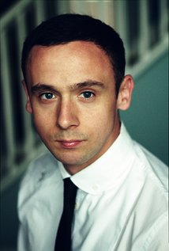

Starting out life as an actor in Britain and then making a cross over to producing, which lead to one of my features “BrOTHERHOOD” having huge box office success, has been an incredible journey.

Taking the leap into directing wasn’t really on my radar, that was until the Little Princess landed on my lap. As soon as I read the short story, I fell in love with it; a simple, beautiful tale, which left you feeling warm and with hope. With everything that is going on in the world, I’m happy that I can share this uplifting story.

We had a limited budget, and only one day to shoot but I was fortunate to have BAFTA winner Noel Clarke producing, his many years of experience as both director and producer meant for a brilliant collaborator, and my stars, Outlander's Steven Cree, who is simply brilliant, and 9-year-old Eloise Graves, who I’m sure is a star in the making.

Much Love,

Jason

