Schutzplan Vollmond (Protection Plan Full Moon)
Synopsis:
(FRA) Un soir de pleine lune dans un centre pour loups-garous en Suisse. Pas facile de se faire comprendre quand on ne parle pas la même langue...

(ENG) On a full moon night in a swiss centre for werewolves. The language barrier might cause some problems...

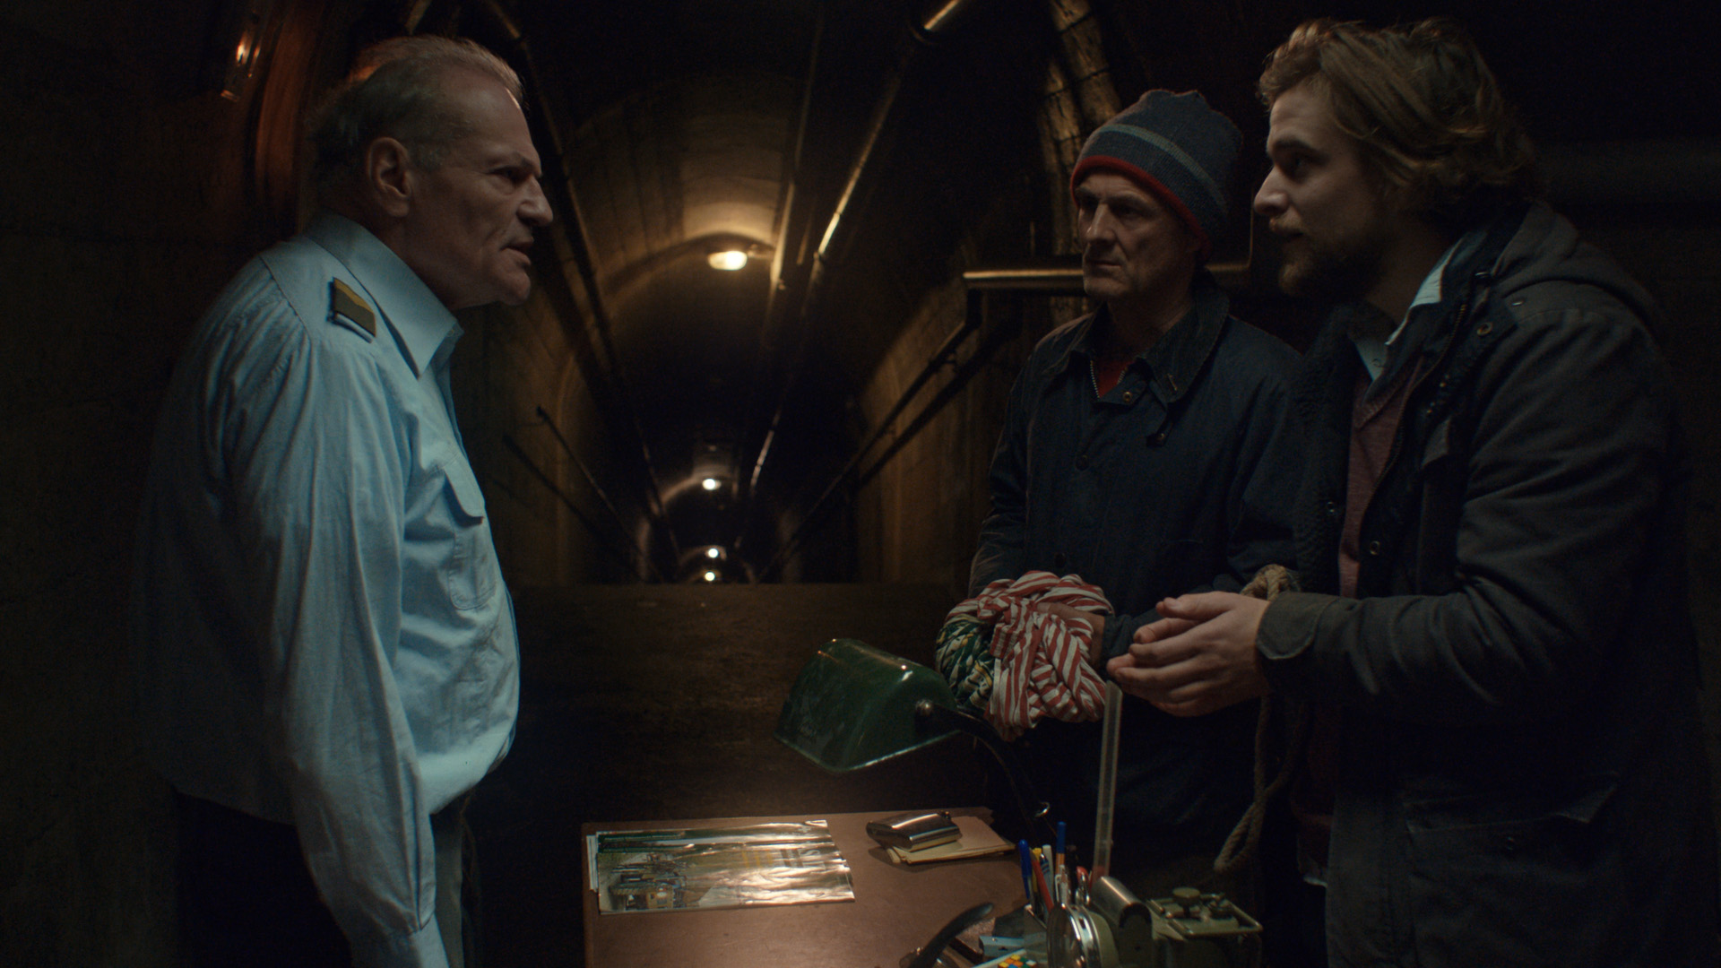
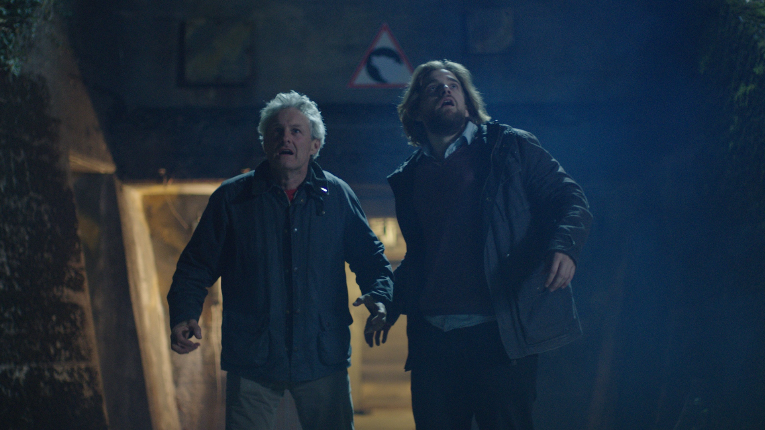

Original title
Schutzplan Vollmond (Protection Plan Full Moon)
Genre
Comedy, fantasy
Language
Swiss german and french
Subtitles
French, english, german
Runtime
08:51
Technical characteristics
Color 1.78 - ProRes444 - DCP 5.1

End of production
June 2017
Country of production
Switzerland
Producer
Zürcher Hochschule der Künste
FIlippo Bonacci
Pfingstweidstrasse 96, 8031 Zürich
filippo.bonacci@zhdk.ch
+41 43 446 32 82
World Sales
Zürcher Hochschule der Künste
Laura Zimmermann
Pfingstweidstrasse 96, 8031 Zürich
laura.zimmermann@zhdk.ch
+41 43 446 31 12
Contact
Elias Jutzet
Le Burkli 83, CH 2019 Chambrelien
eliasjutzet@outlook.com
+41 78 889 71 06
Elias Jutzet, 24 years old, grew up in the french speaking part of Switzerland. He is now studying in the german speaking part of Switzerland for a Bachelor of arts in film at the Zurich University of the Arts.

Filmography: le Prix à Payer, la Dernière Garde, Auf Messers Schneide

Cast
Yves Raeber Raphaël Tschudi Bruno Kocher

Credits
Director and writer - Elias Jutzet
Director assistant - Fabienne Koch
Director of photography - Rafael Kistler
Camera assistant - Lukas Graf
Head lighting technician - Ennio Ruschetti
Lighting technician - Robin Disch
Sound operator - Urs Berlinger
Production designer - Vicky Dovat
Production designer assistant - Elia Quadri
Costumes - Vicky Dovat, Elias Jutzet
Production assistant - Kenneth Gilomen
Catering - Thomas Zimmermann, Robin Gerber
Editor - Elias Jutzet
Special effects - Ennio Ruschetti
Color grading - Robin Disch
Music - Thierry Epiney
Sound design - Elias Jutzet
Sound mixing - Gregg Skerman
Project tutor - Stefan Jäger
Producer - Filippo Bonacci
Bachelor of Arts in Film, ZHdK Manager - Bernhard Lehner

