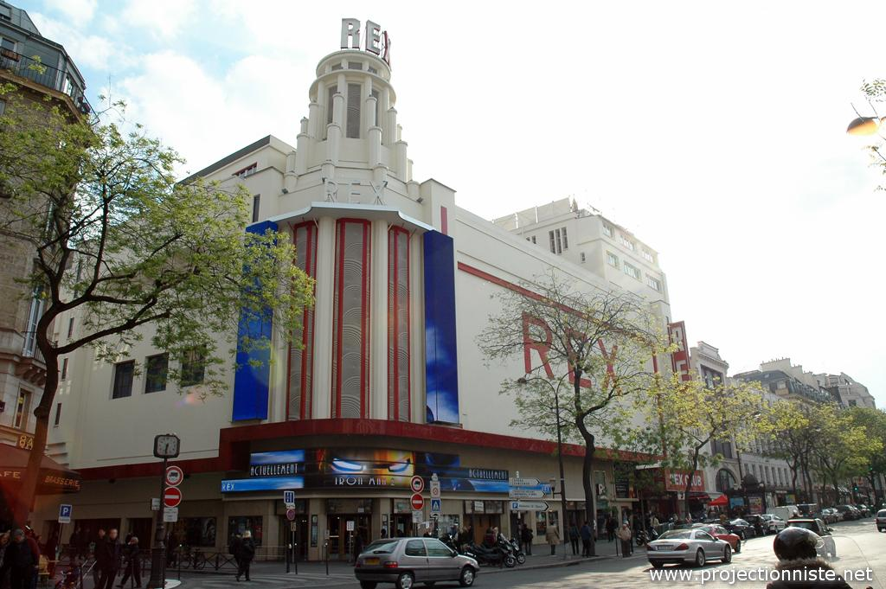

Max et ses filles
Une comédie de Delphine Berger et de Tonie Béhar
D’après le roman de Tonie Béhar « Grands boulevards »(Editions JC Lattès)

Delphine Berger
06.60.17.21.58
d.berger@delfilms.com

- INT / DAY. ADVERTISING SET – TOILETS

DORIA

So? Where are the microbes ?

- INT / DAY. ADVERTISING SET

DIRECTOR
Cut! Doria, what are you doing?
SOPHIE
It's not really yourthing the housework, my darling!

DORIA
No but it's still my allergies (She sneezes). You know that it's Max's birthday tomorrow
SOPHIE
Still as odiously cracking?
DORIA
Always ! He invited me to dinner with him ... with Alice.
SOPHIE
Max and his daughters! Small family gathering around the pater familias!
DORIA
Yeah ... I'm always happy to see Dad, but my sister!
SOPHIE.
It's true she's boring.

DORIA
In fact, I would like to find a picture of us 2 when I was young with Max. And stick it under his nose!

SOPHIE
But you know, I burned everything when Max left me. I was so devastated!
DORIA
My poor “ mamounette” with a broken heart! It must have been horrible!
SOPHIE
Yes ! Atrocious. My darling, don’t you think you should find a real job?
DORIA
Mom, please!
SOPHIE
You're worth better than this.
DIRECTOR
Doria, we're going back!
DORIA
Saved by the gong!

- INT / NIGHT. APARTMENT MAX. DINING ROOM

MAX
Thank you my daughters for coming in, we do not see each other often enough.
ALICE
Whose fault is it !
DORIA
I wouldn’t miss your good food and your birthday for nothing in the world.
MAX
I'll get the cake.
DORIA
No, let me go!
ALICE
Of course!

- INT / EVENING. LIVING ROOM

MAX
Oh thank you Alice ... Ah tell me you know me!
FRED
Max is a Cuban! It will stick you to the ceiling.
MAX
Thanks you guys too. Well, we taste this whiskey
Max opens the bottle of whiskey and serves several glasses.
ALICE
I was hoping you'd calmed down, whiskey, cigars, not to mention poker! It's not good for an elderly person. Doria, you're really irresponsible.
MAX
Listen, my darling, when I need a nurse, I'll pay for it!

DORIA
It's okay ! Max is not crumbling either! He is still much younger than some quadra we know!
MAX
We did not talk about a poker game?

FRED
I'm hot! I'll rip you all!

ERIC
Oh no, not poker! We'll be back in no time.

MAX
It's always the right time for a poker, right?

ERIC
Baby ... do we go home?

- INT / EVENING. DINING ROOM

ALICE
But what are doing all the girls gathered in the back of the yard that we saw when we arrived?

FRED
That's true ! There was a lot of chicks, eh!
MAX
They are there for the mischievous drink organized by Manuela, the patroness of "Oh my Gode! ". It's a sale of sextoys around a glass of champagne.
ALICE
An apero-whore!
DORIA
Whaou! Subtle it!

ALICE
Sorry?

DORIA
Why whores? It's just girls like you and me.

ALICE
Calm down, I'm joking.

DORIA
It's kind of a Tupperware meeting ...

ERIC
Honey, let go
DORIA
I think you should go and see, it would relax you!
FRED
Yes! Ambiance 50 shades of toys. With handcuffs, riding crops ...
ALICE
I do not understand why you keep inviting her when it's not even really your daughter.
MAX
My poor Alice, even on my birthday you can’t help but say bullshit!
DORIA
No, but you know what, let the dad speak. Since the time she leaves me the same barat. What's your problem ?
DORIA
Go ahead, say it. Make yourself happy!
MAX
Doria, play! Please.
DORIA
No, but after 27 years, it might be time to break the abscess!

MAX
He ho! Girls! Be nice, we do not play very often together!
DORIA
You know what, take that, it will give you a little courage!

MAX
Okay guys, we're going to have a last drink at Karim's?

ERIC
Oh no ! Not a glass yet!

FRED
Could we go to the mischievous drink?

- INT / NIGHT. BAR

FRED
Happy Birthday Max.

MAX
Thank you

FRED
Come on, to yours.

ERIC
Happy Birthday Max

- INT / NIGHT. APARTMENT MAX. LIVING ROOM / CORRIDOR / KITCHEN

DORIA
No, but what are you doing here? Are you kidding me? You're serious, are you gonna break up?
ALICE
You rot my life! Since you arrived, I didn’t exist anymore for daddy! I feel I disturbed. Besides, you're called like my grandmother.
DORIA
Our grandmother! I would have liked to meet her so much, did you know her?
ALICE
Yes ! Until I was 12, she took care of me when I came to dad's house. And then she died, so Max no longer wanted to see me ... For more than one year!
DORIA
In fact, I know nothing about our family.
ALICE
Basically, Max's great love was his mother. His death destroyed him.
DORIA
I didn’t know.
ALICE
And when I finally had the right to come back Max had changed, and, in Grany's room, there was a 4 year old girl ...
DORIA
What do you mean ? Who ?
ALICE
You! Doria! You would have seen how he pampered you! He did not do half for me.
DORIA
So at 4, I lived here with my mother and Max?

ALICE
What? Your mother? Oh no, your mother has never lived here, either did you! Max never lived with anyone, not even my mother!

DORIA
I don’t understand what you're talking about. Where was I before?
ALICE
You were four when you arrived here. And I started to hate Max while, in fact, I just wanted him to love me ...

DORIA
But he loves you! He loves us all 2, in his own way.
ALICE
Well, because of him, I married Eric. To have a "normal life"! As a result, I feel like being buried alive, I have no more girlfriends, I play no more in poker, I dress up as an ass...
DORIA
It’s true. For clothes I agree!

ALICE
It's because of you too ... I was jealous ... jealous of you. The pretty little Doria, sparkling, that everyone worshiped .... The cool girl, comfortable with sex toys ...
DORIA
It is true that I have some very very cool!

ALICE
You always revered dad, I’ve never understood why? He never gave us what we expect from a father!
DORIA
I just took what he gave me.

- INT / NIGHT. BAR

ERIC
Max, I go before Alice and Doria killed each other. Thank you for the party.
MAX
Kiss my daughter for me.

FRED
Bye !

9. INT / NIGHT. MAX APARTMENT. LIVING ROOM / ENTRANCE.
9Bis. INT / NIGHT. BAR

FRED
So, what are the news from the front?
DORIA
Bloody. Is Max with you?
FRED
Yes
DORIA
Can you stay with him and try to occupy him, please.
FRED
Really? OK if you want.
Haut du formulaire

- INT/ NIGHT. BAR

MAX
Thank you ... Tchao, Fred.

- INT/NIGHT. MAX APARTMENT. ENTRANCE.

DORIA
"... on April 9, 1992, Max Joseph Dahan declared for his daughter, Doria Eva Roche, born on June 14, 1988 in Paris 14th of Sophie Roche ..."

- INT/NIGHT. STAIRCASE. CORIDOR
- INT/NIGHT. LIVING ROOM

MAX
Doria? Are you okay?
DORIA
Alice has exhausted me! Where is Fred?
MAX
He's still in the bar. I like this boy, he's really nice, but ... Are you sure he's a guy for you?

DORIA
Oh no !

- INT DAY. PASSAGE COVERED. COFFEE

SOPHIE
I knew that day would come, with a curious like you. What did you do? Did you search at Max?
DORIA
I inquire as I can! Who is my father?
SOPHIE
What?
DORIA
Max is not my father, he adopted me?
SOPHIE
But what do you imagine?
DORIA
So what is that? Why a late recognition of paternity? Why a change of name?
SOPHIE
As you know ... I've always been deep in my work ... without seeing the time going on. One day my biological clock began to sound the alarm! Then I met Max, oh my god he was so beautiful! Irresistible! Cool, cultivated, a little bit bad boy ... So, I thought, it's time, it's him, and I did the right thing ...
DORIA
So what? You adopted me! I'm not your daughter either!
SOPHIE
Doria, no! I got pregnant.
DORIA
So what? He left you when he knew?
SOPHIE
No ... I did not tell him.
DORIA
What? But it's disgusting!
SOPHIE
But I knew his opinion on children, on couple so I preferred to be silent.
DORIA
But what if he wanted me?
SOPHIE
You're dreaming my girl! There was nothing to hope for, and I got out of his life, on tiptoe ... with a baby in memory.
DORIA
Yeah! So you made him a child in his back, what! And then they say it's Max the bastard!
SOPHIE
In fact, I did not mean to tell him but ... you asked me so many questions ... so I called him ...
DORIA
And?
SOPHIE
He saw you and he cracked!
DORIA
So without my bad character and my sickly curiosity, I would never have had a father!
SOPHIE
You did the right thing, my darling.

- INT/ DAY. COFFEE

DORIA
So all that for that! All these anxieties, this impression of being always beside my pumps permanently. May be, my allergies are because of you!
SOPHIE
But how could you have doubted that Max was your father? You're just like him. So much more than Alice!
DORIA
It is not false! Perhaps, she’s not even his daughter!

