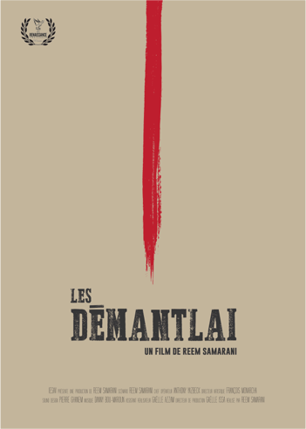

Runtime 22:17 minutes
Language: French/English subtitles. Genre: Western Comedy
IESAV

LOGLINE

A divided family has 48 hours to make an important decision: to unite in exchange of an inheritance.

SYNOPSIS

Two clans, sworn enemies, living under the same roof. Welcome to the Demantlai’s. The unusual harmony within the family will be disrupted following the death of Uncle Maurice. They learn that the deceased bequeaths to them all his fortune under one condition : that they unite again. They have 48 hours to take their decision or the money will be frozen.

BIOGRAPHY

Reem Samarani (Writer & Director)

Reem Samarani, born in Lebanon in 1994, spent her childhood between the United Arab Emirates and her home city of Beirut. She later went on to study cinematography at the University of Saint Joseph in Beirut where she got the opportunity to write and direct three short films. Along the way, she developed a cinematographic language riddled with symbolism. Her films tend to examine controversial topics and critical issues, such as the ethical and social conflicts of her home country, by means of irony and humor. She recently graduated in 2017 and is currently going to pursue a master’s degree in Paris.

DIRECTOR’S STATEMENT

http://nrff.co.uk/nrff-interviews-director-reem-samarani

Les Démantlai is the story of a divided dysfunctional family that has 48 hours to make the difficult decision of uniting, in exchange for their inheritance, which is very little time to work out their considerable differences.

Coming from a country that is in a constant discord, I was overwhelmed with the desire to denounce one of its most recurring sources of internal conflict; cultural differences and sectarianism. I always pictured Lebanon as a small family, all its members sharing the same blood, yet divided by religion and politics; forced to live together under the same roof. This thematic is as applicable at the scale of a nation as it is to a much smaller scale of social groups, such as families. For this reason, I decided to anchor the storyline without a specific spatio temporal setting, in order to truly focus on the familial aspect. The Demantlai’s seem to live in another dimension, one which seems to be their own illusion. Hence the caricature and amplified aspects of the film, which gave it its Cowboys vs Indians undertones. However, I did not wish to create a “society”, but simply speak of ours; a distortion of reality in its honest and raw portrayal. For this reason, I decided to to keep away from Manichaeism, where the boundaries between the good and the bad evaporate. In "Les Démantlai", we do not have one clan portrait in a better light then the other. Blinded by hate and desire of inheritance, everyone is as guilty as the other.

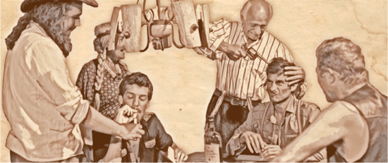

CAST

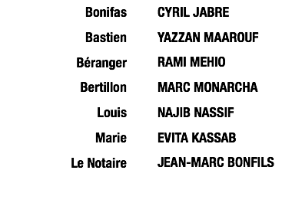

PRODUCTION

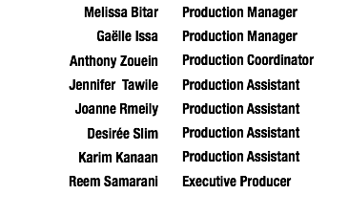

DIRECTING

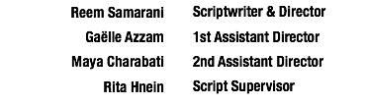

CAMERA & LIGHTING

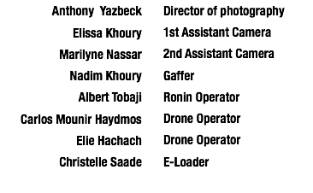

ART DEPARTMENT

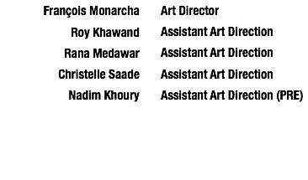
COSTUME & MAKEUP

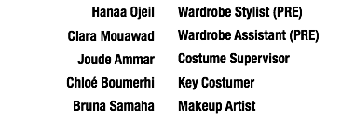

SOUND & MUSIC

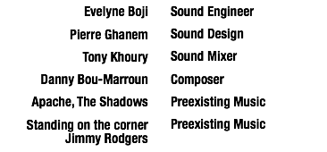

EDITING

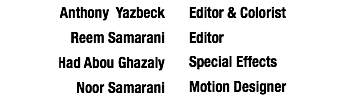

AWARDS & NOMINATIONS

