PRESS PACK “BJARNE HATES THE CAMERA”
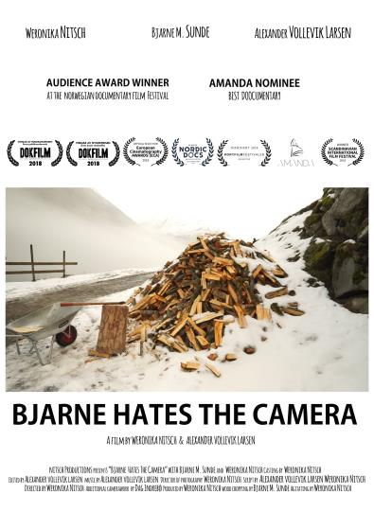
Synopsis:
“Bjarne Hates the Camera” is the story of a foreign filmmaker who invades the life of her neighbour Bjarne. Who is he? She asks him about life and death, hopes and dreams. He asks if she ́s going to stop anytime soon. But when the woman behind the camera refuses to stop, a relationship rarely caught on film is born - full of absurdities, warmth and humour. And mostly just a bunch of unanswered questions.
Storyline:
A foreign filmmaker, invades the life of her neighbour Bjarne who unwillingly becomes main character in a documentary about himself.
Staff:
Directed by/ Produced by/Filmed by/Written by Weronika Nitsch
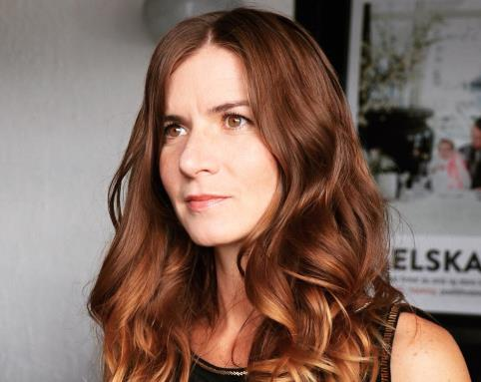
Weronika Nitsch was born on October 14, 1981 in Poland. After receiving her Master's Degree in Dramaturgy at the Jagiellonian University in Poland, she studied Documentary Photography as well as Documentary Journalism at Volda University College in Norway. She also studied Documentary Photography and Directing for Documentary at the University of South Wales in Cardiff. She currently works as a high school photography and film teacher at Sogndal High School in Norway.
Film Editing by/ Music by/ Written by Alexander Vollevik Larsen
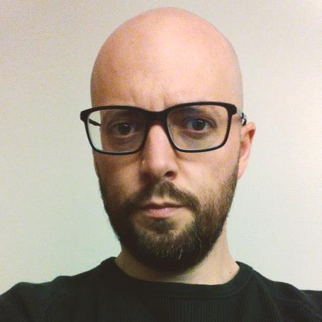
Alexander Vollevik Larsen was born on August 18th, 1982 in Norway. He has a bachelor’s degree in Film and TV from the University of Bergen and started working as a camera man and TV editor at TV2 and Bergens Tidende in his hometown. In 2009 he started working for the Norwegian national broadcaster NRK, making TV series and documentaries.
Additional Camerawork / Aerial Photography by Dag Indrebø
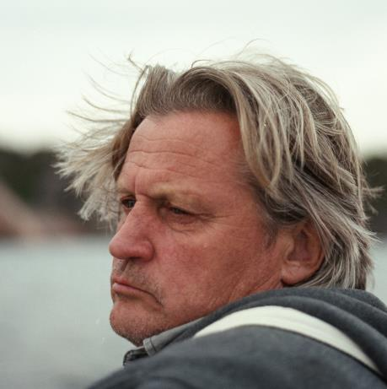
Dag Indrebø, born on January, 3, 1960. Documentary photographer for Norwegian Broadcasting Corp. since 1981.

Cast:
Bjarne Magnar Sunde, Weronika Nitsch

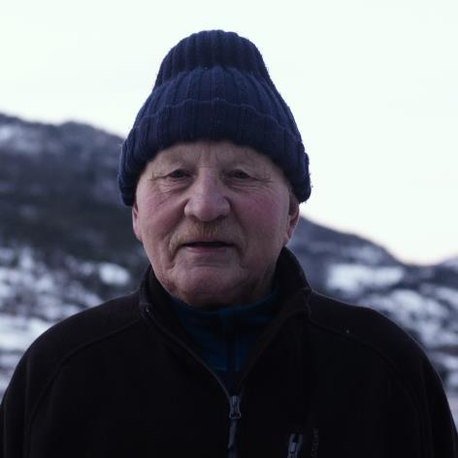

Awards:
Audience Award – Dokfilm 2018, Volda
Best Student Documentary – Dokfilm 2018, Volda
Best Short Documentary – Scandinavian International Film Festival, Helsinki
Best Short Documentary (40-60 min.) Nordic/DOCS 2018, Fredrikstad
Honorable Mention – The Norwegian Short Film Festival, Grimstad
Nomination for Amanda Award 2018 – Category: Best Documentary

